Report about France Vacances

Inception phase  
The first thing we did in this project for France Vacances was in the Inception phase. In the inception phase you validate the costs compared to budget, how long it will take to make and if it’s actually worth it to make an app for specifically this company.   
The first thing we did during the work of France Vacances was that we analyzed the business to be able to conclude if the relevance of an actual app for rental sales was a need for the company.   
In this case we used 4 methods to analyze the business France Vacances.   
  
**The first analysis we used in this case was making a Business Model Canvas.** The Business Model Canvas is used to gain an overview of a business’s value(s), their customers and communication with customers, their key partners and the costs vs revenue.   
Below is Team 7-11’s version of the Business Model Canvas of France Vacances’ business:

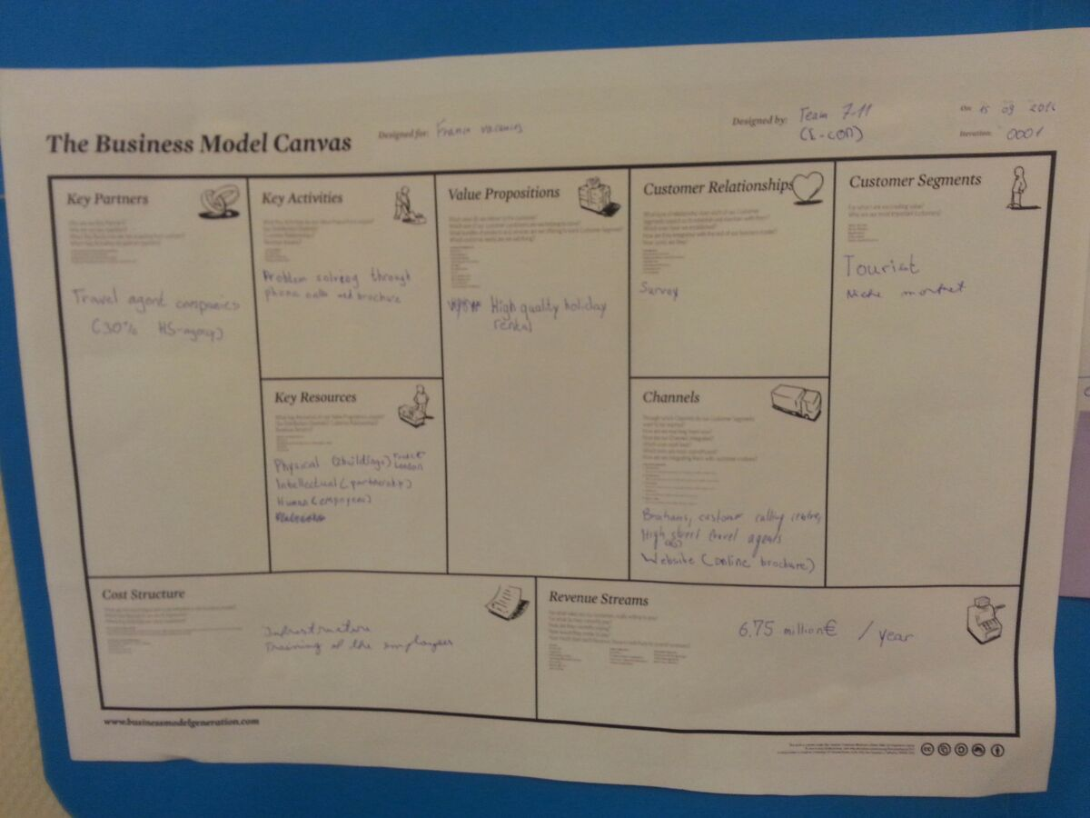

One of the important things to note about the Business Model Canvas of France Vacances is the fact that they are a travel agency and not a rental company. That means they provide the rental but not actually own the rental.   
  
After the Business Model Canvas for France Vacances where we got an overview over the company’s values and communication with customers, we made a **SWOT analysis of the company and the idea of an internet booking service**. SWOT analysis stands for Strengths, Weaknesses, Opportunities and Threats. This analysis is used to get an overview of the companies’ internal (Strengths vs Weaknesses) and external (Opportunities vs Threats) situation.  
Below is “Team 7-11”’s version of the SWOT analysis:

Things to note about the SWOT analysis 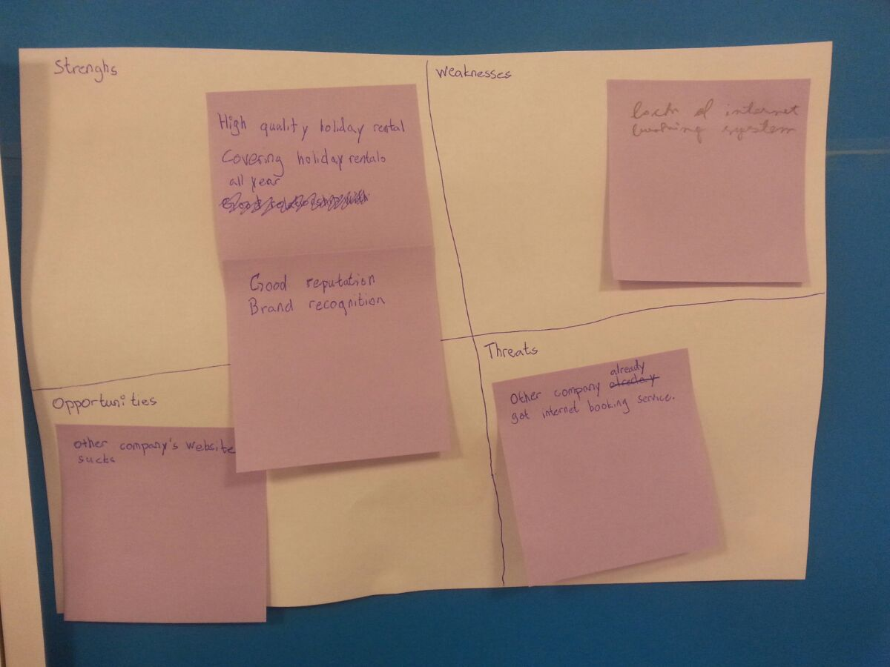is the fact that internet booking is already an ongoing idea during the time of this analysis and it’s both an opportunity and a threat: Other companies have already started attempting internet booking through apps however those other booking apps don’t work efficiently enough that it’s worth it for the customers to use them. This is an opportunity because France Vacances could also attempt making an app and if it works more effectively than the other companies France Vacances will be able to use this to gain more customers. However, if the other companies manage to somehow refine their apps they will be able to take customers from France Vacances.

**Next we used the Porter’s Five Forces analysis.**   
Porter’s Five Forces can be seen on the analysis below and consist of Threat of New Entrants, Bargaining Power of Buyers, Threat of Substitute Product (or as in this case Service) and lastly the Bargaining Power of Suppliers. All these 4 Forces help support the most powerful force – Rivalry Amongst Competitors.   
The Porter’s Five Forces analysis was in this case used to see how France Vacances’ app effected these Five Forces.

Below is “Team 7-11”’s version of the Porter’s five forces analysis

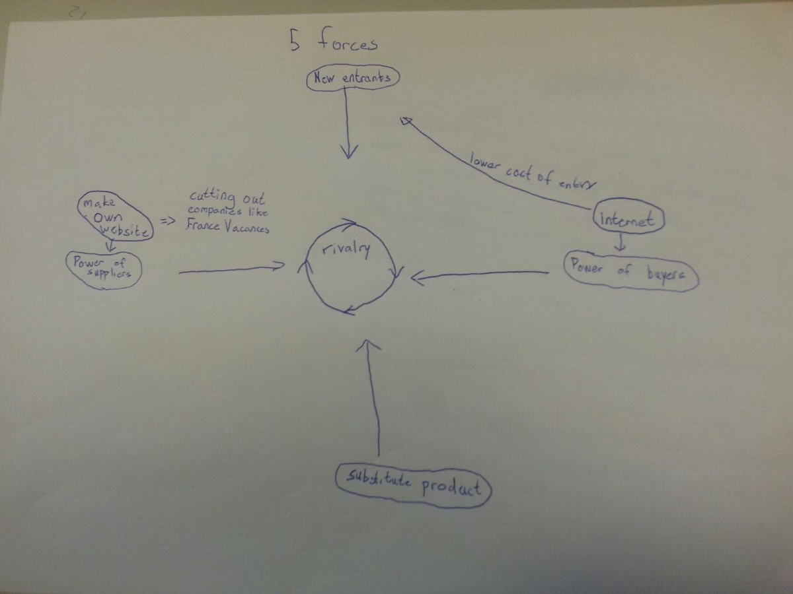

**Last up is the Value Chain analysis.**The Value Chain analysis is an analysis used to find out where your companies’ product / service optimizes the value of the product / service and after the analysis it’s possible to conclude if there’s anywhere the company can refine their value making process like in this case with France Vacances trying to make an app.

Below is “Team 7-11”’s version of the Value Chain analysis 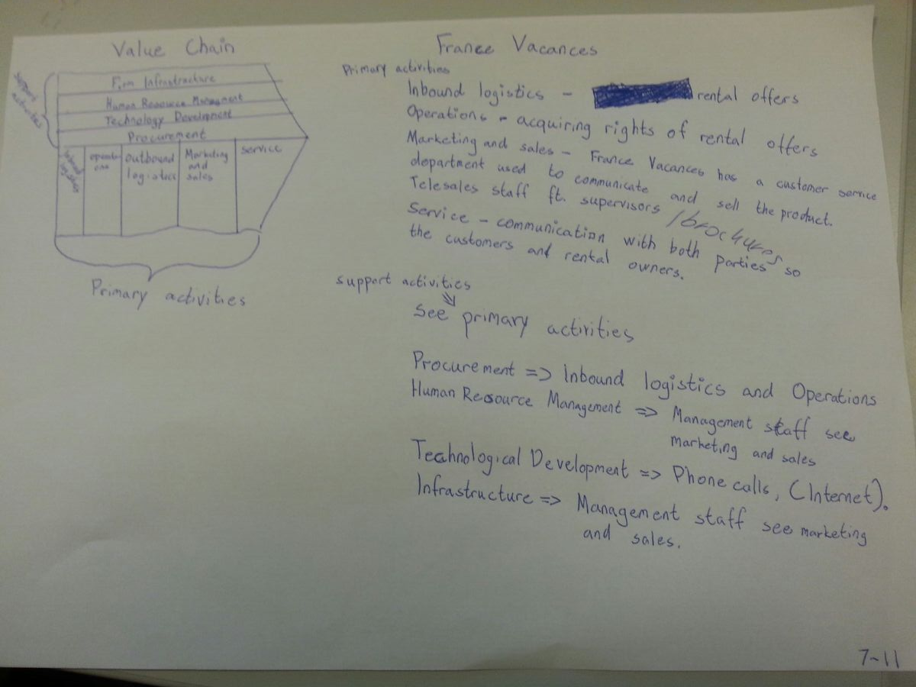

**Partial conclusion**

The result was that an app for France Vacances is crucial.

An app would greatly increase the number of customers for France Vacances and would also provide good advertising. The important thing to note is that the owners of the holiday housing can set up their own web sites as well eliminating the need for a broker like France Vacances. It also reduces the cost of entry for new competition.

A well designed and responsive site would greatly benefit France Vacances.

Elaboration phase  
After having concluded that an app would greatly benefit France Vacances we moved onto the elaboration phase where we started constructing the skeleton / making up a prototype with the use of different artefacts: **Use case**, **class model** and **system sequence diagram**.  
  
When we started working on France Vacances’ app we already had a general idea of what kind of functionalities and screens the actual app should be using. The first design of the UI Interface became the general model of the app and can be seen on the picture below:

Using this UI Interface as our general model we made different artefacts to make up the specific requirements in the app.

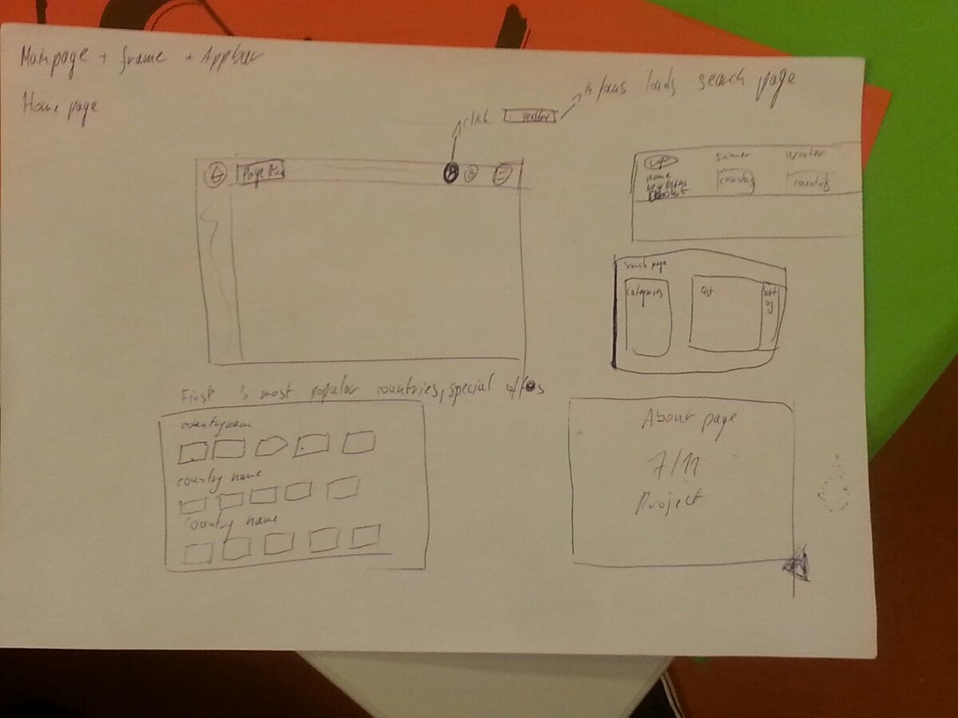 **The first artefact was in this case a Use Case of how the user would interact with the app.**But what is a use case? A use case is a kind of ‘tutorial’ for both the user and the programmer describing a list of actions or event steps that the actor needs to perform together with the system to achieve a goal.   
  
**In the case of France Vacances’ app the use case of booking would look like this:***User starts program and enters welcome / login page. Users logs in or registers an account and the app then redirects the user to the offers page.  
User picks an accommodation* and checks dates of availability. User picks some dates and books a rental.*

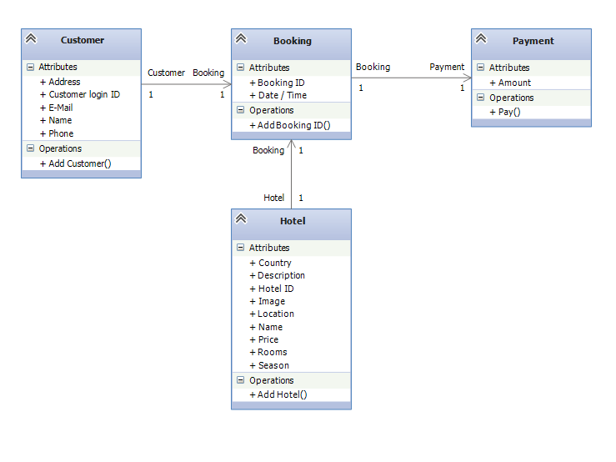*\*Multiple options of accommodation for booking.*After having made the use case for the user’s interaction through the app we could make a **class diagram** of the requirements of classes for making the use case possible. Below is the class diagram with all the required attributes and operations to make the use case possible.

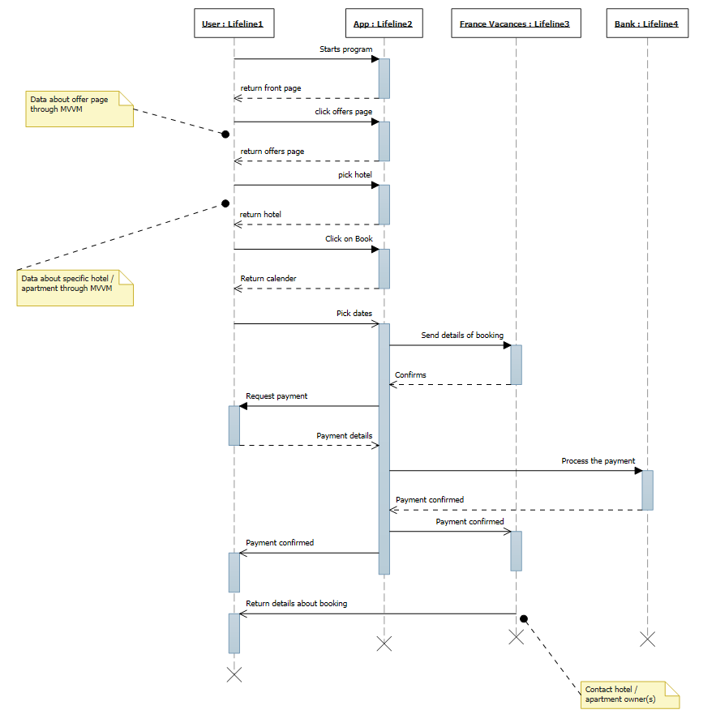  
Lastly, we made a **sequence diagram** to make up how we wanted the user to interact with the app and how the app should communicate with user, France Vacances and bank (as in how payment is processed with the bank / France Vacances).  
**Partial conclusion:**The result of the elaboration phase meant a smooth transition to the next phase: The Construction Phase where we would be programming the actual App including actual design and functionalities.  
  
Construction phase  
After having made a model of the general UI design, having made an actual use case / sequence diagram of the general users interaction through the app and also thought of the requirements of different classes through the class diagram it was now possible to start advancing on constructing the actual app.   
The app uses an EmbeddedFrame and different XAML-View pages which can be redirected to through:   
Interacting with the top Appbar which consists of multiple HyperLinkButtons and a search bar.  
Clicking on one of the multiple rental offers shown on the Home-page.  
Using the Search functionality to search for a specific rental’s name, description etc.  
After having picked a hotel the user can decide to press on book where the app redirects to the final page being the booking page where the user can login / register, pick dates for booking and checkout for payment.  
  
**What we are missing?**  
The User class   
Unit Testing?  
How we use MVVM  
Screenshots of the different pages?